Sign-up for blurbs

Write your name in and unbold

Paste blurb below

---

**S pendant**

BMW gearshifter (Mattan)

**JL pocket watch**

**Japanese Crest**

**Ceramic Vase replica**

**Goblet**

GE07GE @70 Bowl (Mattan)

**AR Hockey pucks**

**Tri-legged vase**

Zack GP ‘Z’ Bowl (Mattan)

**Wooden conductor baton**

**Light switch panel**

**Guitar string fruit bowl**

**Macro paddle with A inlay**

**Plywood bowl**

**Micro paddle**

Lucky puck @500 Limited edition hockey pucks (Mattan)

**T tea box**

**Juniper bowl**

**---**

**COMPLETED/PENDING BLURBS**

**M Gearshift**

This project was a surprise gift for Abba’s son Mattan, made stealthily and swiftly over a two-week period when he was away travelling. It was made to replace the 17-year-old gearshift knob on a 2002 BMW 530i. A cheap replacement knob was purchased online and disassembled to harvest the inner plastic hub that connects to the transmission. A custom “M” emblazoned blank was created and then coopered to the classic shape.

The “M” is particularly fitting as the first letter in Mattan’s name and also as homage to the classic BMW M series decal.

**GE07GE @70**

The GE07GE bowl was a gift for a good friend, George, for his 70th birthday. The blank was fashioned from a repeating “GE” block surrounding a central “70”. Visually, the 70 registers also as the letters “or”, especially when viewed in reverse. With a bit of suspended disbelief, the word “GE07GE” appears in multiple directions surrounding the number 70.

The bowl is an example of some of Abba’s early work in shallow bowls with a prominent scalloped edge.

**Lucky Pucks @500**

The Lucky Pucks @500 custom wooden puck replicas were a gift to Abba’s teammates to commemorate 500 games over more than 10 years. The Lucky Pucks are a special group of dedicated hockey bums that play a weekly hockey game. The group could be called a beer league, but that would not do justice to the level of organization and commitment that the group shows week after week.

Each player received a custom, (almost) identical puck, cut from a long blank first turned on the lath and then backed on a piece of solid maple. The size and tapered edges are just like a real hockey puck. The dotted line is reminiscent of the centre line on a standard ice hockey rink.

**-- Insert picture here ---**

Each puck came with a crafted wooden display stand.

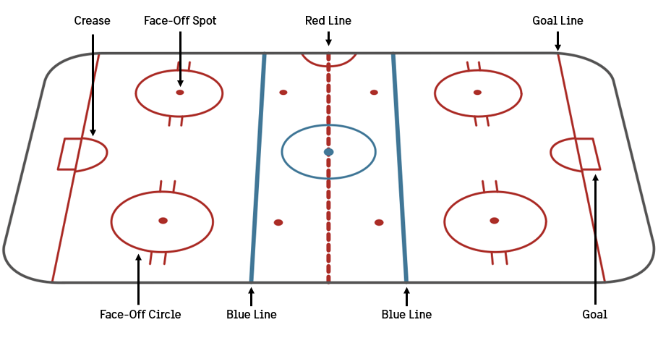

**Zack GP Bowl**

The ZGP bowl was a project that Abba’s son envisioned as a Secret Santa gift for a close friend Zack (an accomplished designer and woodworker himself).

The design is inspired by the letter “Z” which which zips in and out of a maple background as a streak of walnut punctuated by two abrupt corners. The corners curl subtly up the side of the bowl. After much pondering and back-and-forth, Abba and Mattan decided to make the edges of bowl scalloped to preserve the size and heftiness of the bowl.

**-- INSSERT PIC---**

As shown here, an efficient design was planned to limit the number of cuts and maximize the size of the blank with a limited piece of maple.